chapter 1 the human



# the human

* Information i/o … – visual, auditory, haptic, movement
* Information stored in memory – sensory, short-term, long-term
* Information processed and applied

– reasoning, problem solving, skill, error

* Emotion influences human capabilities
* Each person is different

# Vision

Two stages in vision

* physical reception of stimulus
* processing and interpretation of stimulus

# The Eye - physical reception

* mechanism for receiving light and transforming it into electrical energy
* light reflects from objects
* images are focused upside-down on retina
* retina contains rods for low light vision and cones for colour vision
* ganglion cells (brain!) detect pattern and movement

# Interpreting the signal

• Size and depth

* visual angle indicates how much of view object occupies

(relates to size and distance from eye)

* visual acuity is ability to perceive detail

(limited)

* familiar objects perceived as constant size

(in spite of changes in visual angle when far away)

* cues like overlapping help perception of size and depth

# Interpreting the signal (cont)

* Brightness
  + subjective reaction to levels of light
  + affected by luminance of object
  + measured by just noticeable difference
  + visual acuity increases with luminance as does flicker
* Colour
  + made up of hue, intensity, saturation
  + cones sensitive to colour wavelengths
  + blue acuity is lowest
  + 8% males and 1% females colour blind

# Interpreting the signal (cont)

* The visual system compensates for:
  + movement
  + changes in luminance.
* Context is used to resolve ambiguity
* Optical illusions sometimes occur due to over compensation

# Optical Illusions

the Ponzo illusion the Muller Lyer illusion

# Reading

* Several stages:
  + visual pattern perceived
  + decoded using internal representation of language
  + interpreted using knowledge of syntax, semantics, pragmatics
* Reading involves saccades and fixations
* Perception occurs during fixations
* Word shape is important to recognition
* Negative contrast improves reading from computer screen

# Hearing

* Provides information about environment: distances, directions, objects etc.
* Physical apparatus:
  + outer ear – protects inner and amplifies sound
  + middle ear – transmits sound waves as vibrations to inner ear

|  |  |
| --- | --- |
| – inner ear  • Sound | – chemical transmitters are released and cause impulses in auditory nerve |
| – pitch | – sound frequency |
| – loudness | – amplitude |
| – timbre | – type or quality |

# Hearing (cont)

* Humans can hear frequencies from 20Hz to

15kHz

* + less accurate distinguishing high frequencies than low.
* Auditory system filters sounds
  + can attend to sounds over background noise.
  + for example, the cocktail party phenomenon.

# Touch

* Provides important feedback about environment.
* May be key sense for someone who is visually impaired.
* Stimulus received via receptors in the skin:
  + thermoreceptors – heat and cold
  + nociceptors – pain
  + mechanoreceptors – pressure

(some instant, some continuous)

* Some areas more sensitive than others e.g. fingers.
* Kinethesis - awareness of body position – affects comfort and performance.

# Movement

* Time taken to respond to stimulus: reaction time + movement time • Movement time dependent on age, fitness etc. • Reaction time - dependent on stimulus type:
  + visual ~ 200ms
  + auditory ~ 150 ms
  + pain ~ 700ms
* Increasing reaction time decreases accuracy in the unskilled operator but not in the skilled operator.

# Movement (cont)

• Fitts' Law describes the time taken to hit a screen target:

Mt = a + b log2(D/S + 1)

where: a and b are empirically determined constants

Mt is movement time

D is Distance

S is Size of target

⇒ targets as large as possible distances as small as possible

# Memory

There are three types of memory function:

Sensory memories



Short-term memory or working memory



Long-term memory

Selection of stimuli governed by level of arousal.

# sensory memory

* Buffers for stimuli received through senses
  + iconic memory: visual stimuli
  + echoic memory: aural stimuli
  + haptic memory: tactile stimuli
* Examples
  + “sparkler” trail
  + stereo sound
* Continuously overwritten

# Short-term memory (STM)

• Scratch-pad for temporary recall

* rapid access ~ 70ms
* rapid decay ~ 200ms
* limited capacity - 7± 2 chunks

# Examples

212348278493202

0121 414 2626

HEC ATR ANU PTH ETR EET

# Long-term memory (LTM)

* Repository for all our knowledge
  + slow access ~ 1/10 second
  + slow decay, if any
  + huge or unlimited capacity
* Two types
  + episodic – serial memory of events
  + semantic – structured memory of facts,concepts, skills semantic LTM derived from episodic LTM

# Long-term memory (cont.)

* Semantic memory structure
  + provides access to information
  + represents relationships between bits of information
  + supports inference
* Model: semantic network
  + inheritance – child nodes inherit properties of parent nodes
  + relationships between bits of information explicit
  + supports inference through inheritance

# LTM - semantic network

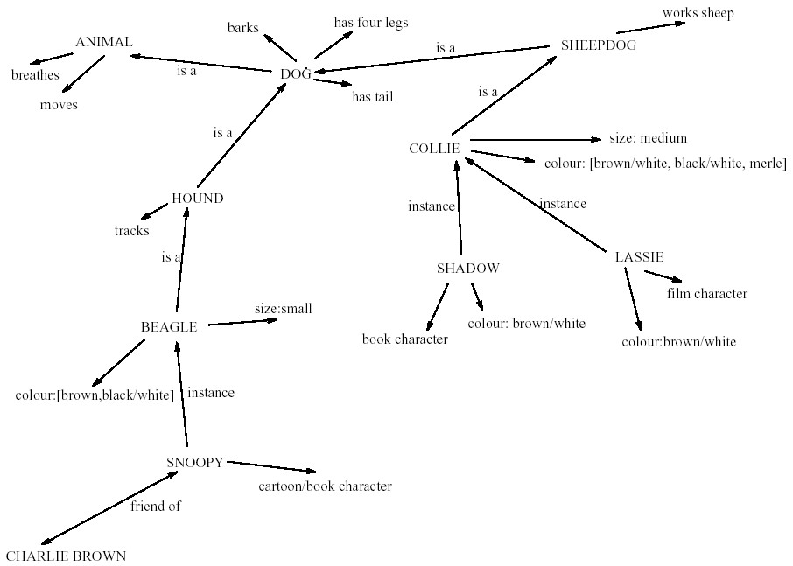

# Models of LTM - Frames

* Information organized in data structures
* Slots in structure instantiated with values for instance of data
* Type–subtype relationships

|  |  |  |
| --- | --- | --- |
| **DOG**  Fixed  legs: 4  Default  diet: carniverous sound: bark  Variable size: colour |  | **COLLIE**  Fixed breed of: DOG type: sheepdog  Default size: 65 cm  Variable colour |

# Models of LTM - Scripts

Model of stereotypical information required to interpret situation

Script has elements that can be instantiated with values for context

|  |  |
| --- | --- |
| **Script for a visit to the vet**  Entry conditions: *dog ill* Roles:  *vet open owner has money*  Result: *dog better*  *owner poorer vet richer*  Scenes:  Props: *examination table*  *medicine instruments* | *vet examines diagnoses*  *treats*  *owner brings dog in*  *pays takes dog out arriving at reception waiting in room examination paying* |
| Tracks: | *dog needs medicine dog needs operation* |

# Models of LTM - Production rules

Representation of procedural knowledge.

Condition/action rules if condition is matched then use rule to determine action.

IF dog is wagging tail

THEN pat dog

IF dog is growling

THEN run away

# LTM - Storage of information

* rehearsal
  + information moves from STM to LTM
* total time hypothesis
  + amount retained proportional to rehearsal time
* distribution of practice effect
  + optimized by spreading learning over time
* structure, meaning and familiarity – information easier to remember

# LTM - Forgetting

decay

* information is lost gradually but very slowly interference
* new information replaces old: retroactive interference
* old may interfere with new: proactive inhibition

so may not forget at all memory is selective …

… affected by emotion – can subconsciously `choose' to forget

# LTM - retrieval

recall

* information reproduced from memory can be assisted by cues, e.g. categories, imagery

recognition

* information gives knowledge that it has been seen before
* less complex than recall - information is cue

Thinking

Reasoning

deduction, induction, abduction

Problem solving

# Deductive Reasoning

* Deduction:

– derive logically necessary conclusion from given premises.

e.g. If it is Friday then she will go to work

It is Friday

Therefore she will go to work.

* Logical conclusion not necessarily true:

e.g. If it is raining then the ground is dry

It is raining

Therefore the ground is dry

# Deduction (cont.)

* When truth and logical validity clash …

e.g. Some people are babies

Some babies cry

Inference - Some people cry Correct?

* People bring world knowledge to bear

# Inductive Reasoning

* Induction:

– generalize from cases seen to cases unseen

e.g. all elephants we have seen have trunks therefore all elephants have trunks.

* Unreliable:

– can only prove false not true … but useful!

* Humans not good at using negative evidence

e.g. Wason's cards.

# Wason's cards

|  |
| --- |
| **7** |

**E 4 K**

If a card has a vowel on one side it has an even number on the other

Is this true?

How many cards do you need to turn over to find out?

…. and which cards?

# Abductive reasoning

* reasoning from event to cause

e.g. Sam drives fast when drunk.

If I see Sam driving fast, assume drunk.

* Unreliable:

– can lead to false explanations

# Problem solving

* Process of finding solution to unfamiliar task using knowledge.
* Several theories.
* Gestalt
  + problem solving both productive and reproductive
  + productive draws on insight and restructuring of problem
  + attractive but not enough evidence to explain `insight' etc.
  + move away from behaviourism and led towards information processing theories

# Problem solving (cont.)

Problem space theory

* problem space comprises problem states
* problem solving involves generating states using legal operators
* heuristics may be employed to select operators

e.g. means-ends analysis

* operates within human information processing system

e.g. STM limits etc.

* largely applied to problem solving in well-defined areas

e.g. puzzles rather than knowledge intensive areas

# Problem solving (cont.)

* Analogy

– analogical mapping:

* novel problems in new domain?
* use knowledge of similar problem from similar domain

– analogical mapping difficult if domains are semantically different

• Skill acquisition

* skilled activity characterized by chunking • lot of information is chunked to optimize STM
* conceptual rather than superficial grouping of problems
* information is structured more effectively

# Errors and mental models

Types of error

* slips
  + right intention, but failed to do it right – causes: poor physical skill,inattention etc.
  + change to aspect of skilled behaviour can cause slip
* mistakes
  + wrong intention
  + cause: incorrect understanding

humans create mental models to explain behaviour. if wrong (different from actual system) errors can occur

# Emotion

* Various theories of how emotion works
  + James-Lange: emotion is our interpretation of a physiological response to a stimuli
  + Cannon: emotion is a psychological response to a stimuli
  + Schacter-Singer: emotion is the result of our evaluation of our physiological responses, in the light of the whole situation we are in
* Emotion clearly involves both cognitive and physical responses to stimuli

# Emotion (cont.)

* The biological response to physical stimuli is called *affect*

* Affect influences how we respond to situations
  + positive → creative problem solving
  + negative → narrow thinking

“Negative affect can make it harder to do even easy tasks; positive affect can make it easier to do difficult tasks”

(Donald Norman)

# Emotion (cont.)

• Implications for interface design

* stress will increase the difficulty of problem solving
* relaxed users will be more forgiving of shortcomings in design
* aesthetically pleasing and rewarding interfaces will increase positive affect

# Individual differences

* long term
  + sex, physical and intellectual abilities
* short term
  + effect of stress or fatigue
* changing – age

Ask yourself: will design decision exclude section of user population?

Psychology and the Design of

# Interactive System

* Some direct applications
  + e.g. blue acuity is poor

⇒ blue should not be used for important detail

* However, correct application generally requires understanding of context in psychology, and an understanding of particular experimental conditions
* A lot of knowledge has been distilled in
  + guidelines (chap 7)
  + cognitive models (chap 12)
  + experimental and analytic evaluation techniques (chap 9)